**Jeremy Rios-Martinez**

**COMSC 265**

**Lab 9**

**Exercise 1 Word Count program**

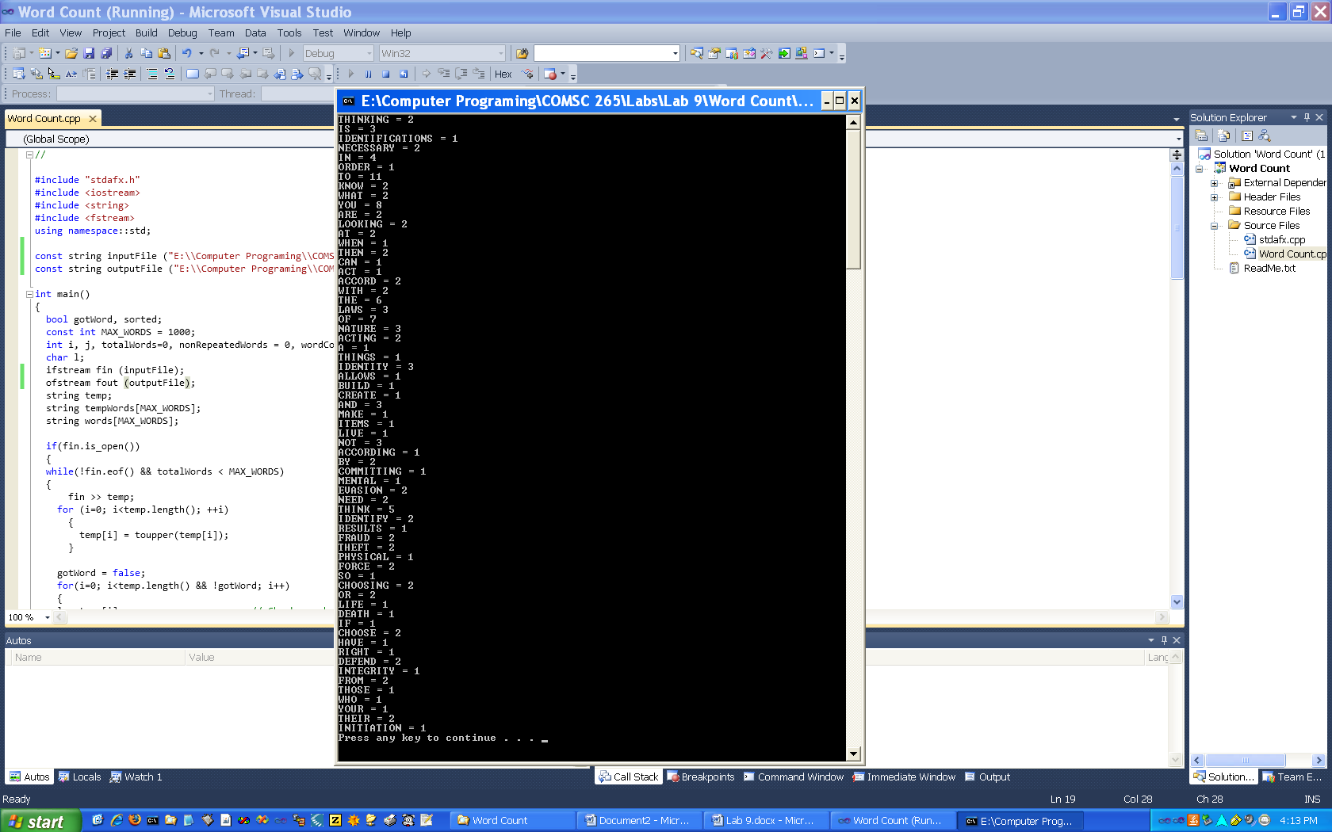

**Exersice 2 Encode/Decode program**

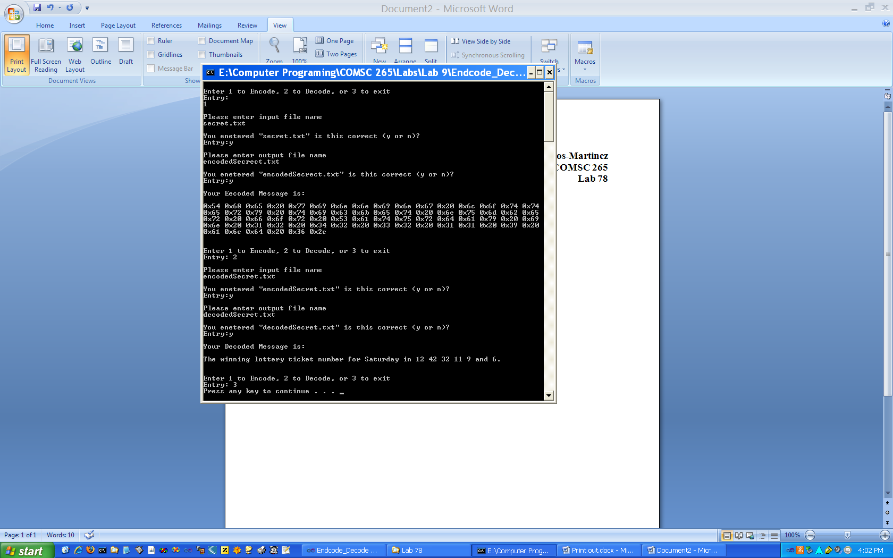

**Exersize 3 Statistics Program**

